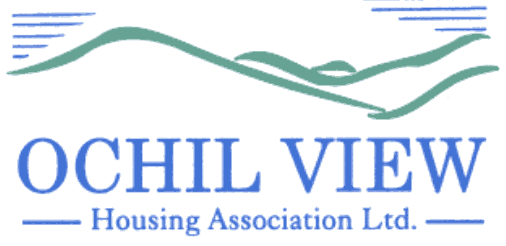

NOTICE OF BOARD OF MANAGEMENT MEETING TO BE HELD ON THURSDAY 25TH SEPTEMBER 2025 AT 6PM AT OCHIL HOUSE, ALLOA AND ON MS TEAMS

AGENDA

- Recording of Meeting (No Papers)
FOR APPROVAL / TO BE MINUTED

- Election of Office Bearers (No Papers)
FOR DECISION

  - Chairperson
  - Vice Chairperson
  - Treasurer
  - Executive Committee – Tenant Representative

- Apologies

- Declarations of Interest (No Papers)
TO BE RECORDED

- Minutes of Board of Management meeting held on 28th August 2025 (Enclosed)
FOR APPROVAL AND SIGNATURE

- Matters Arising from Item 5.0

- Commercially Sensitive Extract of the Minutes of Board of Management meeting held on 28th August 2025 (Enclosed) FOR APPROVAL AND SIGNATURE

- Matters Arising from Item 7.0

- Private & Confidential Extract of Minute of the Board of Management Meeting held on 28th August 2025 (Enclosed) FOR APPROVAL & SIGNATURE

- Matters Arising from Item 9.0

- Private & Confidential Minute of the Executive Committee meeting held on 25th August 2025 (Enclosed)
FOR APPROVAL AND SIGNATURE

- Matters Arising from Item 11.0

- Private & Confidential Minute of the Executive Committee meeting held on 4th September 2025 (Enclosed) FOR APPROVAL AND SIGNATURE

- Matters Arising from 13.0

- Draft Minute of AGM of 11th September 2025 (Enclosed) FOR INFORMATION

- Committee Remits and Composition of Board / Committees 2025/2026 (Report from the Chief Executive Enclosed) FOR APPROVAL

- Code of Conduct for Governing Body Members 2025 (Report from the Chief Executive Enclosed) FOR APPROVAL

- Board of Management Declarations of Interest (Report from the Chief Executive Enclosed) FOR INFORMATION

- SHAPS Pension Valuation 2024 (Report form the Chief Executive Enclosed) FOR DECISION

- Minutes of the Health, Safety and Environment / Human Resources Committee Meeting held on 18th September 2025 (Enclosed) FOR INFORMATION

  - Remote Working Policy 2025 FOR APPROVAL
  - Dependent Care Leave Policy 2025 FOR APPROVAL

- Governance/Other Issues

  - SHR Landlord Report (Enclosed) FOR INFORMATION
  - Board Strategy Day Draft Agenda (Enclosed) FOR INFORMATION

- EVH Matters:

22.1 Monthly Report September 2025 (Enclosed) FOR INFORMATION

- AOCB

- Date of Next Meeting 30th October 2025

Anne Smith
Chief Executive

16th September 2025

