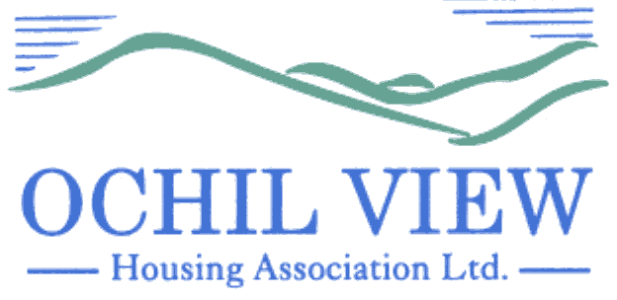

NOTICE OF BOARD OF MANAGEMENT COMMITTEE MEETING TO BE HELD AT OCHIL HOUSE (AND REMOTELY VIA MS TEAMS) ON THURSDAY 28th AUGUST 2025 at 6pm

AGENDA

- Recording of Meeting (No Papers)
FOR APPROVAL / TO BE MINUTED

- Apologies

- Declarations of Interest (No Papers)
TO BE RECORDED

- Minutes of Board of Management meeting held on 31st July 2025 (Enclosed)
FOR APPROVAL AND SIGNATURE

- Matters Arising from Item 4.0

- Private and Confidential Extract of Minutes of Board of Management Meeting held on 31st July 2025 (Enclosed) FOR APPROVAL AND SIGNATURE

- Matters Arising from Item 6.0

- Annual Assurance Statement 2025 Report (Report from the Chief Executive) FOR APPROVAL

- Board Nominees affected by the 9-year rule (Report from the Chief Executive) FOR APPROVAL

- Roofline Tenders (Report from the Director of Property Services) FOR APPROVAL

- Director of Finance and Corporate Services Recruitment (Report from the Chief Executive) FOR APPROVAL

- Minutes of the Customer Services Committee meeting of 14th August 2025 (Enclosed)
FOR INFORMATION

  - Verbal Report from Convenor (No Papers)
  - Estate Management Policy FOR APPROVAL
  - Void Management Policy FOR APPROVAL

- Board Member Nomination FOR APPROVAL

- Governance Issues FOR DISCUSSION/INFORMATION/APPROVAL

14.1 Board Away Day FOR DISCUSSION

- EVH Business

- A.O.C.B

17.0 Board Members’ Performance and Development Review 2024/25 FOR INFORMATION (PRIVATE & CONFIDENTIAL: FOR BOARD MEMBERS ONLY)

18.0 Evaluation of Chairperson (Report from the Vice-Chairperson) FOR INFORMATION
(PRIVATE & CONFIDENTIAL: FOR BOARD MEMBERS ONLY)

19.0 Warmworks’ Presentation (Presentation by Laura Fordyce, Warmworks)

- Date of Next Meeting 25th September 2025

Anne Smith
Chief Executive

22nd August 2025

