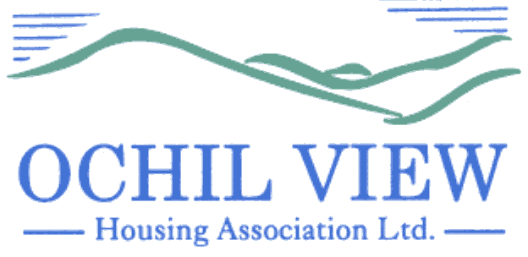

NOTICE OF BOARD OF MANAGEMENT MEETING TO BE HELD AT OCHIL HOUSE (AND VIA MS TEAMS) ON THURSDAY 31ST JULY 2025 at 6pm

AGENDA

- Recording of Meeting (No Papers)
FOR APPROVAL / TO BE MINUTED

- Apologies

- Declarations of Interest (No Papers)
TO BE RECORDED

- Minutes of the Board of Management Meeting held on 26th June 2025 (Enclosed)
FOR APPROVAL AND SIGNATURE

- Matters Arising from Item 4.0

- Commercially Sensitive Minute of the Board of Management Meeting held on 26th June 2025 (Enclosed) FOR APPROVAL AND SIGNATURE

- Matters Arising from Item 6.0

- Private and Confidential Minute of the Board of Management Meeting held on 26th June 2025 (Enclosed) FOR APPROVAL AND SIGNATURE

- Matters Arising from Item 8.0

- Private and Confidential Minute of the Executive Committee Meeting on 30th June 2025 (Enclosed) FOR APPROVAL AND SIGNATURE

- Matters Arising from Item 10.0

- Private and Confidential Minute of the Executive Committee Meeting on 17th July 2025 (Enclosed) FOR APPROVAL AND SIGNATURE

- Matters Arising from Item 13.0

- Impairment Review for 2024/2025 (Report from the Director of Finance and Corporate Services Enclosed) FOR APPROVAL

- Audited Accounts for the year end 31st March 2025 (Report from the Director of Finance and Corporate Services Enclosed) FOR APPROVAL

  - Annual Accounts Report 2025 (Report from the Director of Finance and Corporate Services Enclosed) FOR INFORMATION
  - Letter of Representation to Auditors Alexander Sloan FOR APPROVAL AND SIGNATURE
  - Financial Statements for the year ended 31st March 2025 (To be presented by Alexander Sloan) FOR APPROVAL AND SIGNATURE
  - Audit Summary Report FOR INFORMATION

- Appointment of External Auditors (No Papers)
FOR APPROVAL

17.0 Management Accounts for Period 1st April to 30th June 2025 (Report from the Director of Finance and Corporate Services) FOR APPROVAL

- Quarterly Management Reports for Period 1st April to 30th June 2025 (Reports from the Chief Executive Enclosed) FOR APPROVAL

  - Corporate Performance Report
  - Corporate Management Plan Progress
  - Annual Assurance Statement (DEFERRED)
  - Capital Programme Progress
  - Resident Safety Compliance Report

- Strategic Risk Management Q1 (Report from the Chief Executive Enclosed)
FOR APPROVAL

- Annual General Meeting Report (2) (Report from the Chief Executive Enclosed)
FOR APPROVAL

- Board Nominees Affected by the 9 Year Rule (Report from the Chief Executive DEFERRED) FOR APPROVAL

- Annual Declaration of Compliance with Rules 62 to 67 (Report from the Chief Executive Enclosed) FOR APPROVAL

- Staff Code of Conduct Update (Report from the Chief Executive Enclosed) FOR APPROVAL

- Minutes of the Finance, Audit & Corporate Governance Committee Meeting of 10th July 2025 (Enclosed) FOR INFORMATION

  - Verbal Report from the Convenor (No Papers)
  - Risk Management Framework (Review) FOR APPROVAL

- Governance / Other Board Training Issues
FOR INFORMATION

  - Board Appraisals (Verbal Update)
  - SHAPS Employer Committee Update

- EVH Business:

  - EVH Monthly Report: July 2025 (Enclosed)

- A.O.C.B

- Date of Next Meeting 28th August 2025

Anne Smith
Chief Executive
1ST July 2025

NB

Please note that it would be appreciated if any typographical errors etc could be communicated to me prior to the meeting (preferably by email) so that the relevant amendments can be made in advance of the meeting. Thanks

