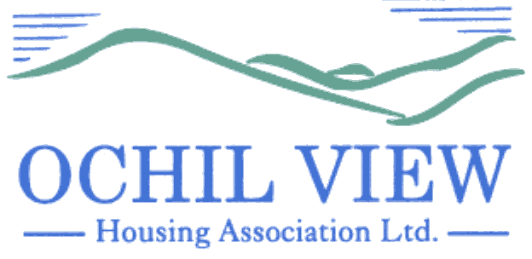

NOTICE OF BOARD OF MANAGEMENT MEETING TO BE HELD AT OCHIL HOUSE, ALLOA AND VIA MS TEAMS ON THURSDAY 24th APRIL 2025 AT 6PM

AGENDA

- Recording of Meeting (No Papers)
FOR APPROVAL / TO BE MINUTED

- Apologies

- Declarations of Interest (No Papers)
TO BE RECORDED

- Minutes of Board of Management Meeting held on 27th March 2025 (Enclosed)
FOR APPROVAL AND SIGNATURE

- Matters Arising from Agenda Item 4.0

- Commercially Sensitive Extract of Minutes of the Board of Management meeting held on 27th March 2025 (Enclosed) FOR APPROVAL AND SIGNATURE

- Matters Arising from Agenda Item 6.0

- Private & Confidential Extract of Minutes of the Board of Management meeting held on 27th March 2025 (Enclosed) FOR APPROVAL AND SIGNATURE

- Matters Arising from Agenda Item 8.0

- Corporate Management Plan (1st Draft) (Report from the Chief Executive) FOR APPROVAL

- Flexible Working Trial (Report from the Chief Executive) FOR APPROVAL

- Social Housing Net Zero Heat Fund Application (Report from the Director of Property Services) FOR APPROVAL

- Minutes of the Customer Services Committee Meeting held on 10th April 2025 (Enclosed) FOR INFORMATION

  - Rent Arrears Policy FOR APPROVAL
  - Scottish Secure Tenancy Agreement FOR APPROVAL
  - Short Scottish Secure Tenancy Agreement FOR APPROVAL
  - Short Scottish Secure Tenancy Agreement (ASB) FOR APPROVAL

- EVH Matters:

  - EVH Monthly Report: April 2025 (Enclosed) FOR INFORMATION

- Governance / Committee Training Issues
  - Board Member Appraisals 2025 (Verbal Update) FOR INFORMATION
  - SFHA Annual Conference 11/12 June (Enclosed) FOR INFORMATION
  - Audit Plan 2025 (Enclosed) FOR INFORMATION
  - Regulatory Engagement Plan 2025 FOR INFORMATION

- A.O.C.B

- Date of Next Meeting 29th May 2025

Anne Smith
Chief Executive

31st March 2025

